# SHEET-9 –USER ACCOUNT MANAGEMENT -II

1. Create a user named raina with the following properties
   1. uid (-u)
   2. gid (-g)
   3. comment (-c)
   4. home directory(-d)
   5. shell (-s)

CMMD : adduser -u 3001 -g 1026 -c”NewUser” -d “/home/NewTest1” -s “/bin/bash” Raina

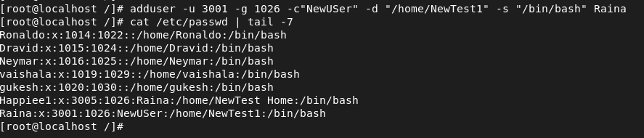

1. set the password for user raina

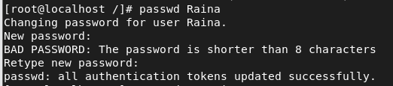

1. check the status of password using – **passwd –S username**



1. check the userinfo values in **etc/passwd.**

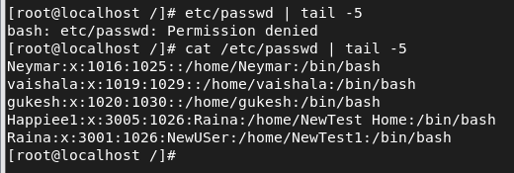

1. Create a new user Virat without home directory (**useradd –M Username**)

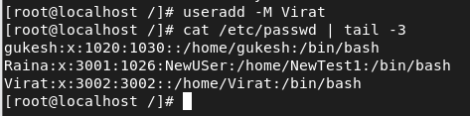

1. Create another user Rahul with account expiry date (**useradd –e ‘yyyy-mm-dd’ username**)



1. Check the user Rahul info using **chage –l username**

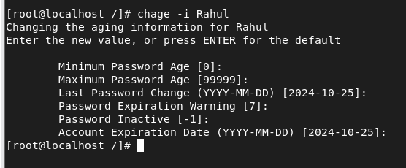

1. Change the user Virat properties using **usermod** cmd.
   1. Uid
   2. Gid
   3. Comment
   4. Home directory
   5. Accout expiry date
   6. Username as Kohli – **usermod –l newname oldname**

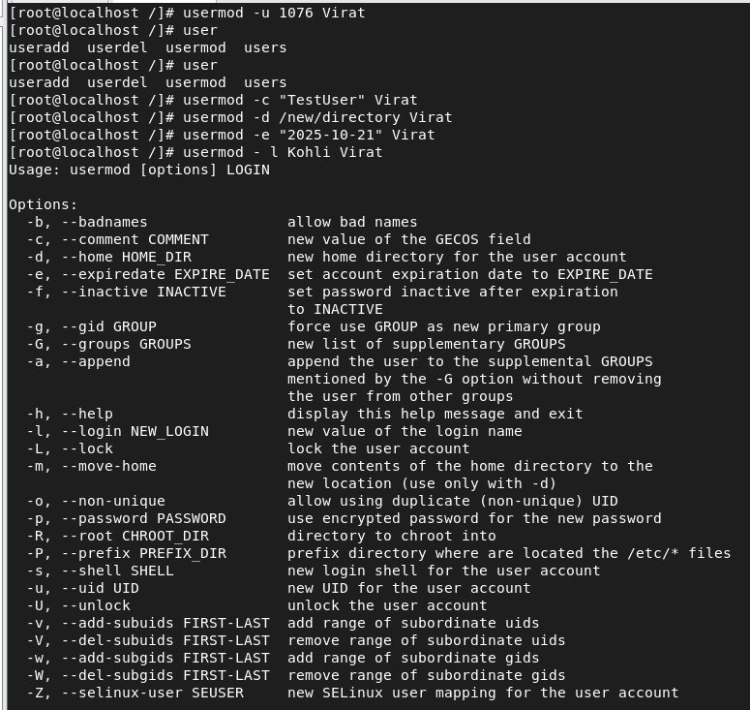

1. Check all these values in **/etc/passwd** and **chage –l username** cmd

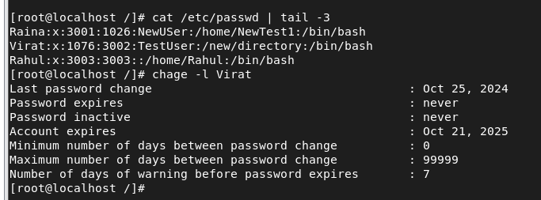

1. Lock the password for user raina using **passwd –l username** and check its status.

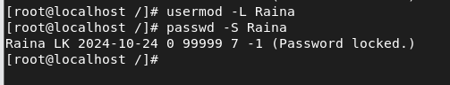

1. Login with user raina from user other than root and observe.

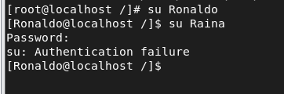

1. Now unlock password for user raina using **passwd –u username** and check its status.

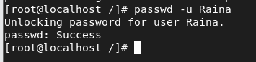

1. Login with user raina from user other than root and observe

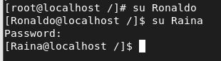

1. Now lock the user account of raina using **usermod –L username** and check.

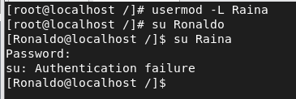

1. Unlock the user account of raina using **usermod –U username** and check.

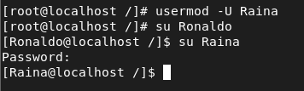

1. Using chage cmd ,perform the following
   1. **Chage –l username** – to check the properties of password (account aging info).

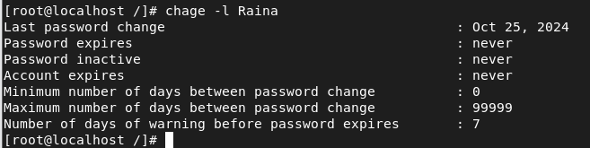

* 1. It can be found in /etc/shadow file also



* 1. Min days for password reset –m

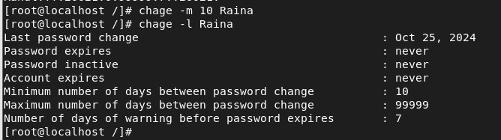

* 1. Max days for password reset –M

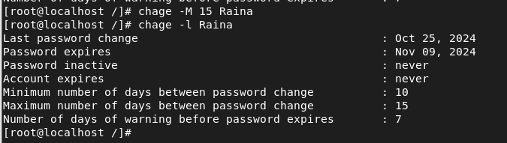

* 1. Warning before password change –W

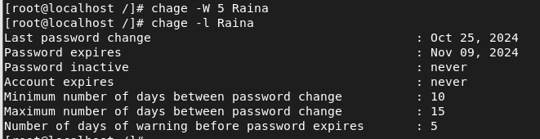

* 1. Inactive days –after which the account will be disabled –I

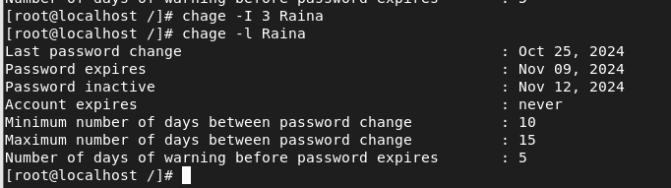

* 1. Last password change date –d



* 1. Account expiry date –E

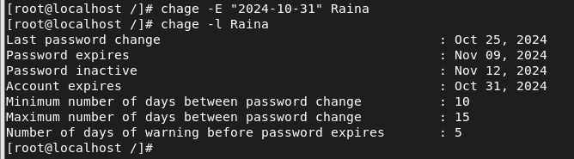

* 1. Check whether all these properties are updated .(**chage –l username**)

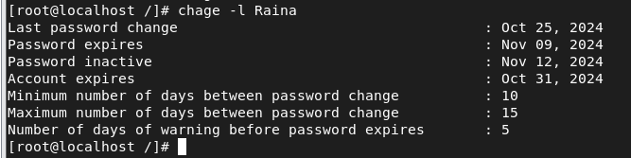

1. Create another user kohli and set kohlis password
   1. Now change last password change date as 0 for kohli(**chage –d 0 username**)

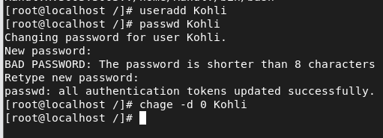

* 1. Login into kohli and check .

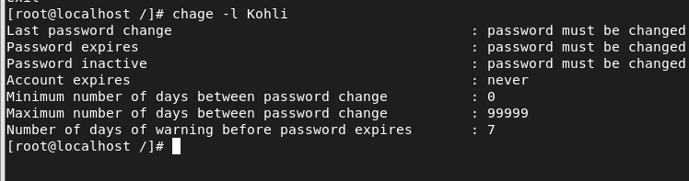

1. Use **groupmod cmd** to perform the following for an existing user raina and group sports
   1. Add user raina to group sports using **usermod –aG grpname username**

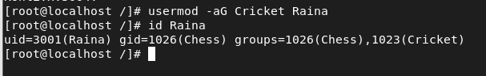

* 1. Add user mahendra to group sports (primary group) – **usermod –g gid/gname username**

i. Use id username cmd to check the groups of user.

* 1. Check the details in **etc/group** file
  2. Use **gpasswd –a user group** to add user kohli to sports

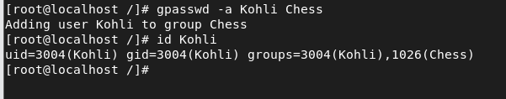

1

# SHEET-9 –USER ACCOUNT MANAGEMENT -II

1. Check the details in **etc/group** file

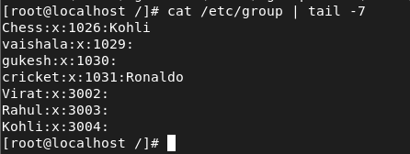

1. Change the groupid of Chess to 4000 – groupmod –g GID groupname

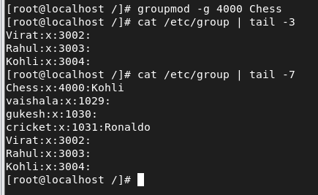

1. Change the groupid of user kohli to 4002 – groupname –g GID username

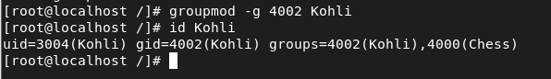

1. Change the groupname from Chess to Chesspersons – groupmod –n newgrp oldgrp
2. Check the details in **etc/group** file

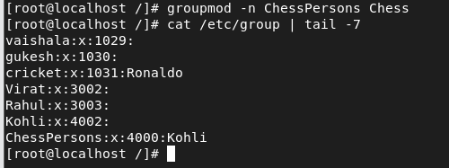

1. Check the default values using **useradd –D**

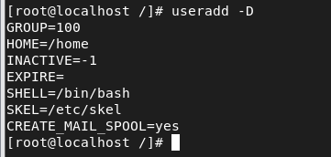

1. Check the default values using cat **/etc/default/useradd**

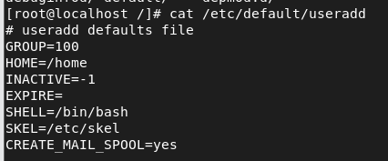

1. Run **ls –l on /home and /var/spool/mail** and observe the user directories

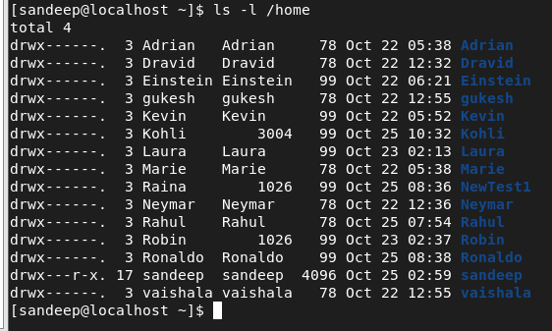

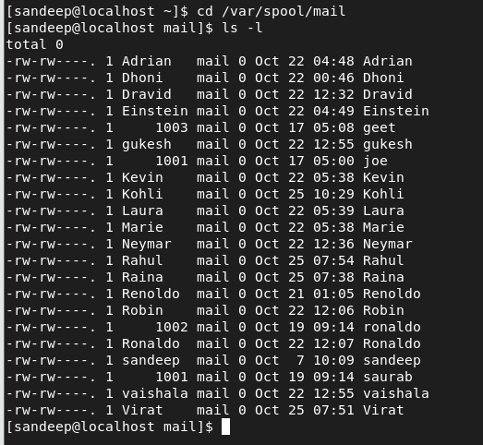

1. Delete a user and chk the mail dircectory

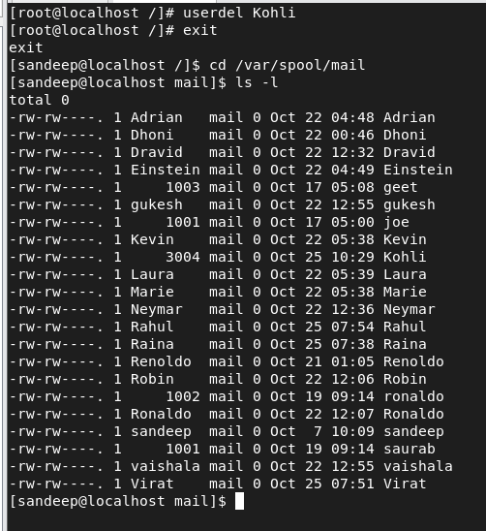

1. Run **ls –la on /etc/skel** directory and observe the default directories and files .(when creating a new user all these will be created in /home/newuser)

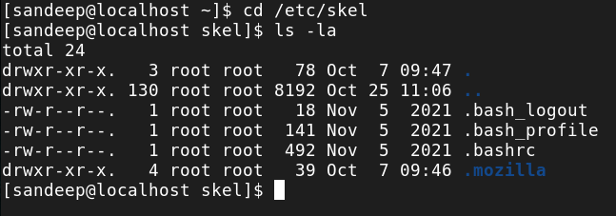

1. Use cmds **id username**, **id –un username** ,**id –gn username**
2. Use **w** ,**last** and **whoami** cmd and observe the result.
3. **Cat /etc/login.defs** file and see the default values.

2